If the depth of a tree is smaller than 5, then this tree can be represented by an array of three-digit integers. For each integer in this array:

* The hundreds digit represents the depth d of this node where 1 <= d <= 4.
* The tens digit represents the position p of this node in the level it belongs to where 1 <= p <= 8. The position is the same as that in a full binary tree.
* The units digit represents the value v of this node where 0 <= v <= 9.

Given an array of **ascending** three-digit integers nums representing a binary tree with a depth smaller than 5, return *the sum of all paths from the root towards the leaves*.

It is **guaranteed** that the given array represents a valid connected binary tree.

**Example 1:**

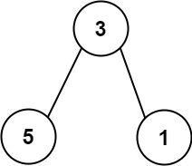

Input: nums = [113,215,221]  
Output: 12  
Explanation: The tree that the list represents is shown.  
The path sum is (3 + 5) + (3 + 1) = 12.

**Example 2:**

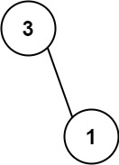

Input: nums = [113,221]  
Output: 4  
Explanation: The tree that the list represents is shown.   
The path sum is (3 + 1) = 4.

**Constraints:**

* 1 <= nums.length <= 15
* 110 <= nums[i] <= 489
* nums represents a valid binary tree with depth less than 5.